New diagnosis codes for COVID-19 immunization status

Just what does ICD code Z28.310: Unvaccinated for COVID-19 mean?
Robert W Malone MD, MS
Jan 25
934

177

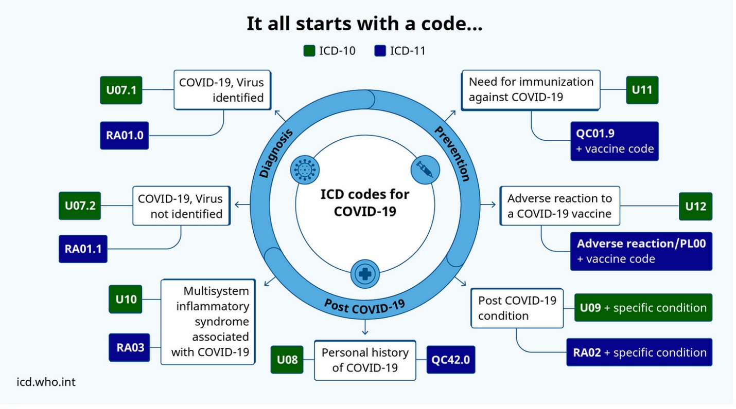

ICD serves a broad range of uses globally and provides critical knowledge on the extent, causes and consequences of human disease and death worldwide via data that is reported and coded with the ICD. Clinical terms coded with ICD are the main basis for health recording and statistics on disease in primary, secondary and tertiary care, as well as on cause of death certificates. These data and statistics support payment systems, service planning, administration of quality and safety, and health services research. Diagnostic guidance linked to categories of ICD also standardizes data collection and enables large scale research.
For more than a century, the International Classification of Diseases (ICD) has been the basis for comparable statistics on causes of mortality and morbidity between places and over time. Originating in the 19th century, the latest version of the ICD, ICD-11, was adopted by the 72nd World Health Assembly in 2019 and came into effect on 1st January 2022.
-World Health Organization (WHO)
The ICD system is used extensively in the USA and the world. With the passage by Congress of the Affordable Care Act (Obamacare) in 2012, the ICD coding system became fully integrated with the digitization of healthcare records in the USA.
According to the Centers for Disease Control (CDC),
“In addition to the main ICD, WHO authorizes the U.S. government to develop a modification for classifying morbidity from inpatient and outpatient records, physician offices, and most National Center for Health Statistics (NCHS) surveys. This modification is known as the International Classification of Diseases, Clinical Modification (ICD-CM).”
This is important, as the WHO is authorizing the US government to modify the classification system to meet specific needs. The ICD classification system is run by the World Health Organization, not the US government.
In April 2022, the federal Centers for Medicare and Medicaid (CMS) announced a new set of codes relating to vaccination status that are cause for concern. These ICD codes are not based on a disease or illness, but are based on COVID-19 vaccination status. It took almost a year, but in January 2023 these codes became available to nearly every medical clinic and hospital in the USA.

CDC updates guidelines for COVID-19 underimmunization codes

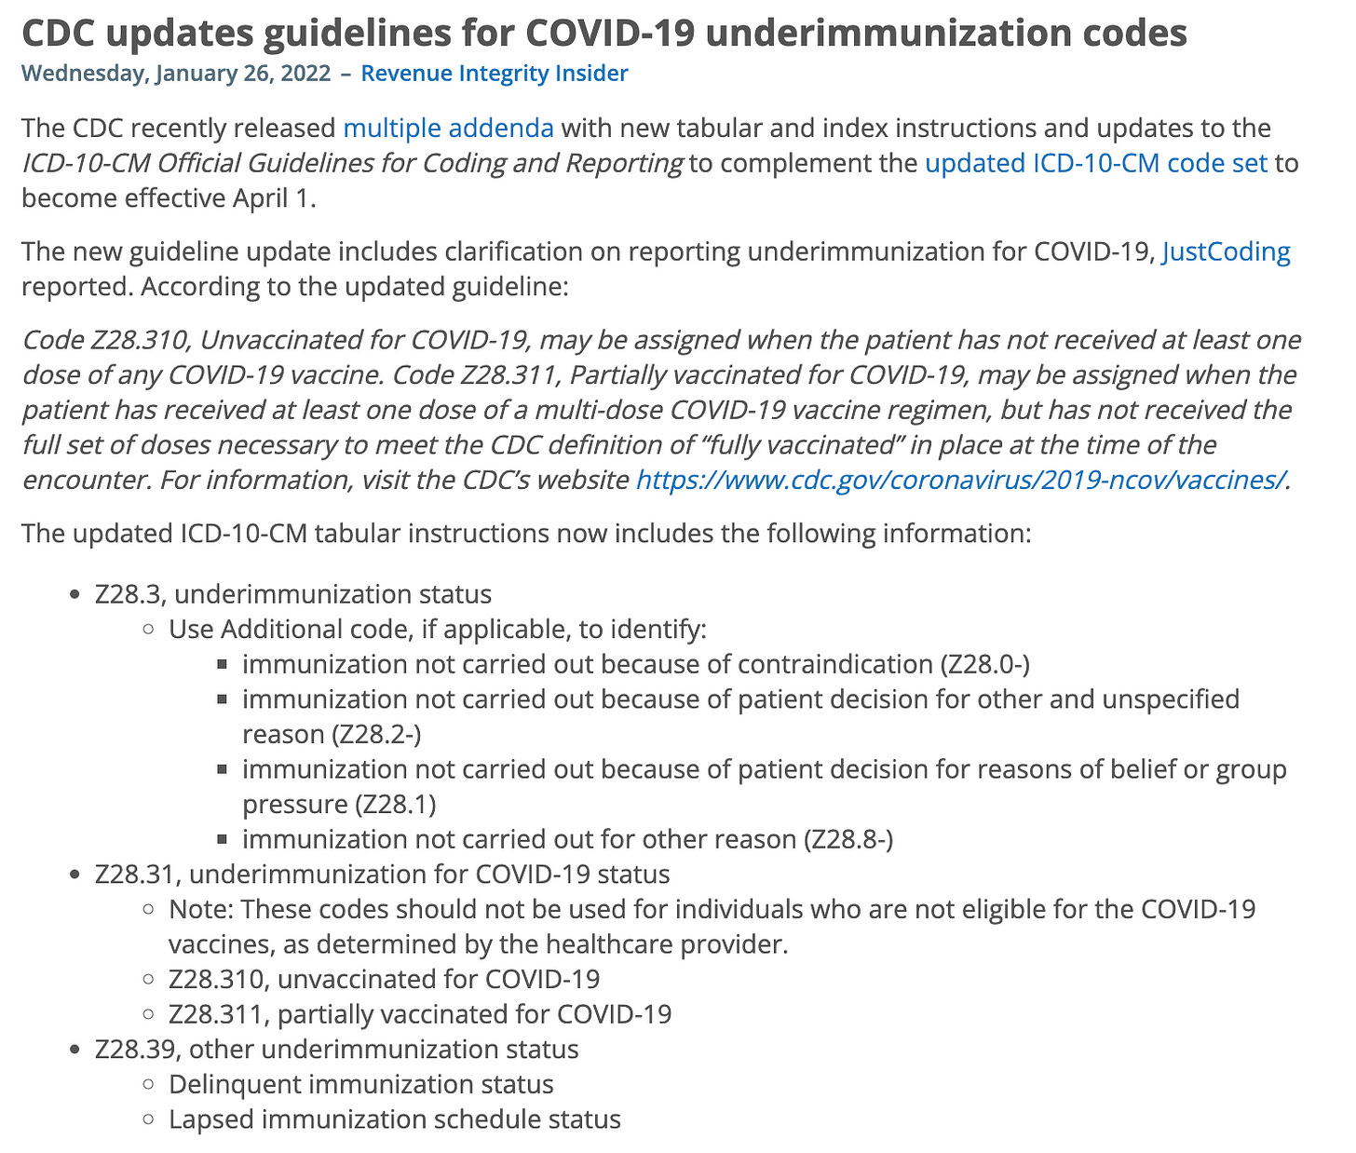

Let me be even more specific, Code Number Z28.310 listed above is not a code for an illness or diagnosis, but rather for non-compliance of a medical procedure. This is an invasion of our right to privacy. There must be choice and that choice must be private.
Once a person’s vaccination status is coded and uploaded into large data base, it can be accessed by government and private health insurers alike. The administrative state officers at the CDC have not made immunization status a reportable disease (yet) but immunization status is listed as one of the reasons for mandatory reporting. They are just one step away from being able to collect this information without your permission. Ergo: vaccine passports made easy.
In this country, not having your vaccine records “up-to-date” might mean:
- The government will not restrict your travel, airlines will.
- The government will not restrict your travel, other nations will.
- The government will not restrict your travel, auto rental companies will.
- The government will not restrict your travel, public transport will.
- The government will not restrict your travel, private companies will.
(Sound familiar)…
The truth is that this information, under law, is not to be shared. The Privacy Act of 1974 should ensure this, but during the COVID-19 vaccine mandates, it did not. Children were not protected from this information being shared with schools. Employees were not protected when employers had the “right” to demand vaccination status information. College students were required to be vaccinated and show proof of vaccination. So, despite there being laws on the books, these laws were and still are being repeatedly broken. I think that in the case of immunization status, the government will have issues with continuing to break the blinds on our health care records. This is not over.
“All Federal agencies must also meet the requirements of the Privacy Act of 1974, which restricts what information about individual citizens – including any personal health information – can be shared with other agencies and with the public.” (HHS.gov)
But the ICD codes go deeper than immunization status and the new codes that I recently uncovered imply that the government has a much darker future in store for us.
There are not only ICD for those that are “under-immunized,” but the World Health Organization and the Federal Centers for Medicare and Medicaid (CMS) have a solution to take care of that. They now have ICD codes to ensure immunization safety counseling. Here is the page for “Z71.85 is a billable ICD-10 code used to specify a medical diagnosis of encounter for immunization safety counseling” Yes, you too can undergo a “re-education” program, or maybe it will be a “re-education” camp targeting children. Yes, a camp has a must softer and gentler meaning, don’t you think? and kids just love going to camp! (Brought to you by Pfizer).
The American Academy of Pediatrics offers the following information about Z71.85 (immunization safety counseling)

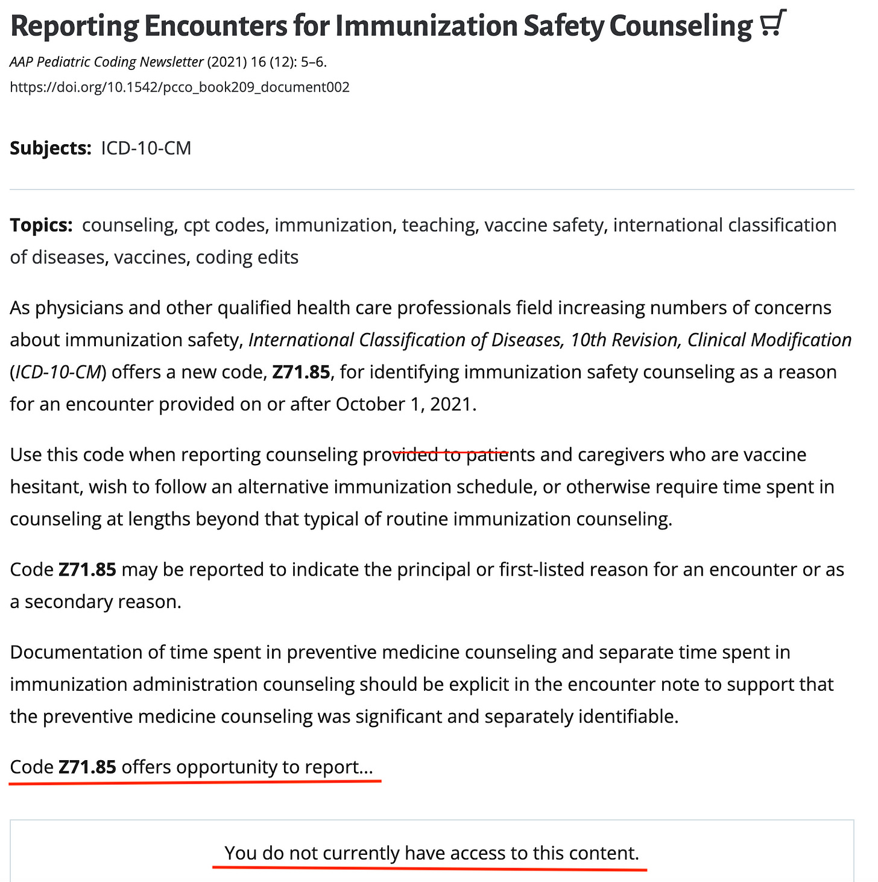

Note: without being a member of American Academy of Pediatrics, I do not have access to discover what “opportunity” I have to “report” on, regarding those who need Z71.85, otherwise known as “immunization safety counseling”…

There is even more evidence that these codes are being implemented nationally:
The American Association of Family Practitioners recently added the following to their website:

New diagnosis codes for COVID-19 immunization status
The Centers for Disease Control and Prevention (CDC) and the Centers for Medicare & Medicaid Services have announced three new diagnosis codes, including two for COVID-19 immunization status. The following codes will be available as of April 1:
- ICD-10-CM Description
- Z28.310 Unvaccinated for COVID-19
- Z28.311 Partially vaccinated for COVID-19
- Z28.39 Other under-immunization status
According to ICD-10-CM guidelines, clinicians may assign code Z28.310, “Unvaccinated for COVID-19,” when the patient has not received a dose of any COVID-19 vaccine. Clinicians may assign code Z28.311, “Partially vaccinated for COVID-19,” when the patient has received at least one dose of a multi-dose COVID-19 vaccine regimen, but has not received the doses necessary to meet the CDC definition of “fully vaccinated” at the time of the encounter. (For information on what constitutes “fully vaccinated,” visit the CDC’s website.) New code Z28.39 is for reporting when a patient is not current on other, non-COVID vaccines.

The administrative state is busy building a vaccine passport system that will be active before most Americans are aware of what is being done to them.
No one is going to knock on your door asking for your vaccine status because they already know. Do you remember on that form at the dentist or doctor’s office asking for your vaccine status, as well as your social security number and date of birth when you checked in for your appointment? All the CDC needs to do is modify slightly the definition of what is a reportable event to include Z28.310 and Z28.311 and they can use this information at will (if they aren’t already under the COVID-19 Public Health Emergency executive order that has again been re-approved by Biden).
They don’t need approval from Congress or the courts because we have given them the information through our health care providers. The CDC is the governmental organization tasked with tracking vaccine status on individuals. They already have the records, as well as updated booster information. They just need to tweak a definition here and there, or get President Biden to keep the COVID-19 public health emergency in place indefinitely and the vaccine passports will be a fait accompli.
The public health emergency gives the federal government wide-ranging authorities over a number of Covid-19-related areas, including data tracking
So, there is nothing to stop them from sharing this information with other governments, schools, airlines, etc. Nothing except us.
The question is, what can be done about it?
The first step is that Congress has to act to finish what the Senate has started by declaring the public health emergency over. The public health emergency must end and the only way for this to happen is for the House to also declare an end to it.

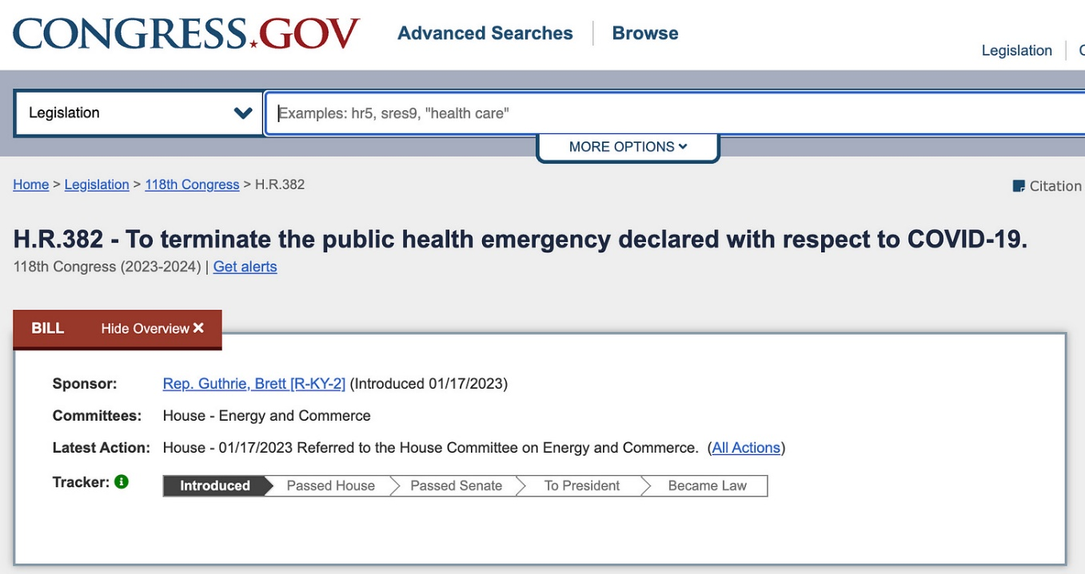

In the end, the solutions have to come from Congress. They have to soundly reject all attempts by the administrative state, the UN, the WHO, HHS and the Biden Administration to require a vaccine passport or a digital ID upon us all. Then they have to work to ensure the freedom of travel for citizens of the United States by standing up for the rights of all.
Contact your congress person and let them know you support the new Select Subcommittee on the Weaponization of the Federal Government to investigate civil liberties issues and how the government and private companies collect and analyze information on Americans. That the formation of this committee is a great start but these committee members have a lot of work to do and we expect answers!
Who is Robert Malone is a reader-supported

